Name: Varia Neel Jitesh
Enrollment No: 250447003019

Network Security And Forensics
Lab Session – 2
Q1. Study and demonstration of network Cable.
Forming of network cable CAT-6 cables
A network cable is a physical medium used to transmit data between computers, switches, routers, and other network devices. Among various types of network cables, CAT-6 (Category 6) cables are widely used in modern Local Area Networks (LANs) due to their high speed and reliability.
What is a Network Cable?
A network cable is a communication cable that carries data signals from one device to another in a wired network. It plays a critical role in ensuring stable, secure, and high-speed data transmission.
Types of Network Cables
- Twisted Pair Cable
  - UTP (Unshielded Twisted Pair)
  - STP (Shielded Twisted Pair)
- Coaxial Cable
- Fiber Optic Cable

CAT-6 Network Cable
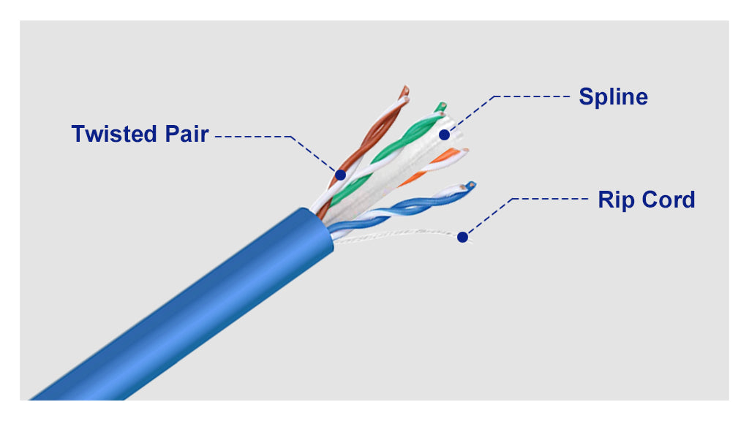

CAT-6 is an advanced Ethernet cable standard designed to support high-speed data transmission up to 1 Gbps (1000 Mbps) and frequencies up to 250 MHz.
Features of CAT-6 Cable
- Supports high data rates
- Reduced crosstalk and interference
- Suitable for Gigabit Ethernet
- Better performance compared to CAT-5e
- Maximum recommended length: 100 meters

Internal Structure
A CAT-6 cable contains:
- 4 twisted pairs (8 wires total)
- Color-coded insulation
- Central spline (in some cables) to reduce interference
- Outer protective jacket

Forming (Crimping) of CAT-6 Network Cable
Required Tools
CAT-6 Ethernet cable & RJ-45 connectors
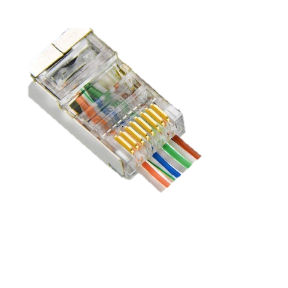
Crimping tool
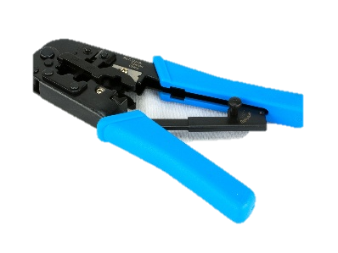
Wire stripper / cutter
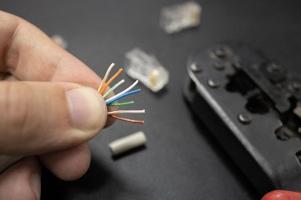

Wiring Standards
Two common wiring standards are used:
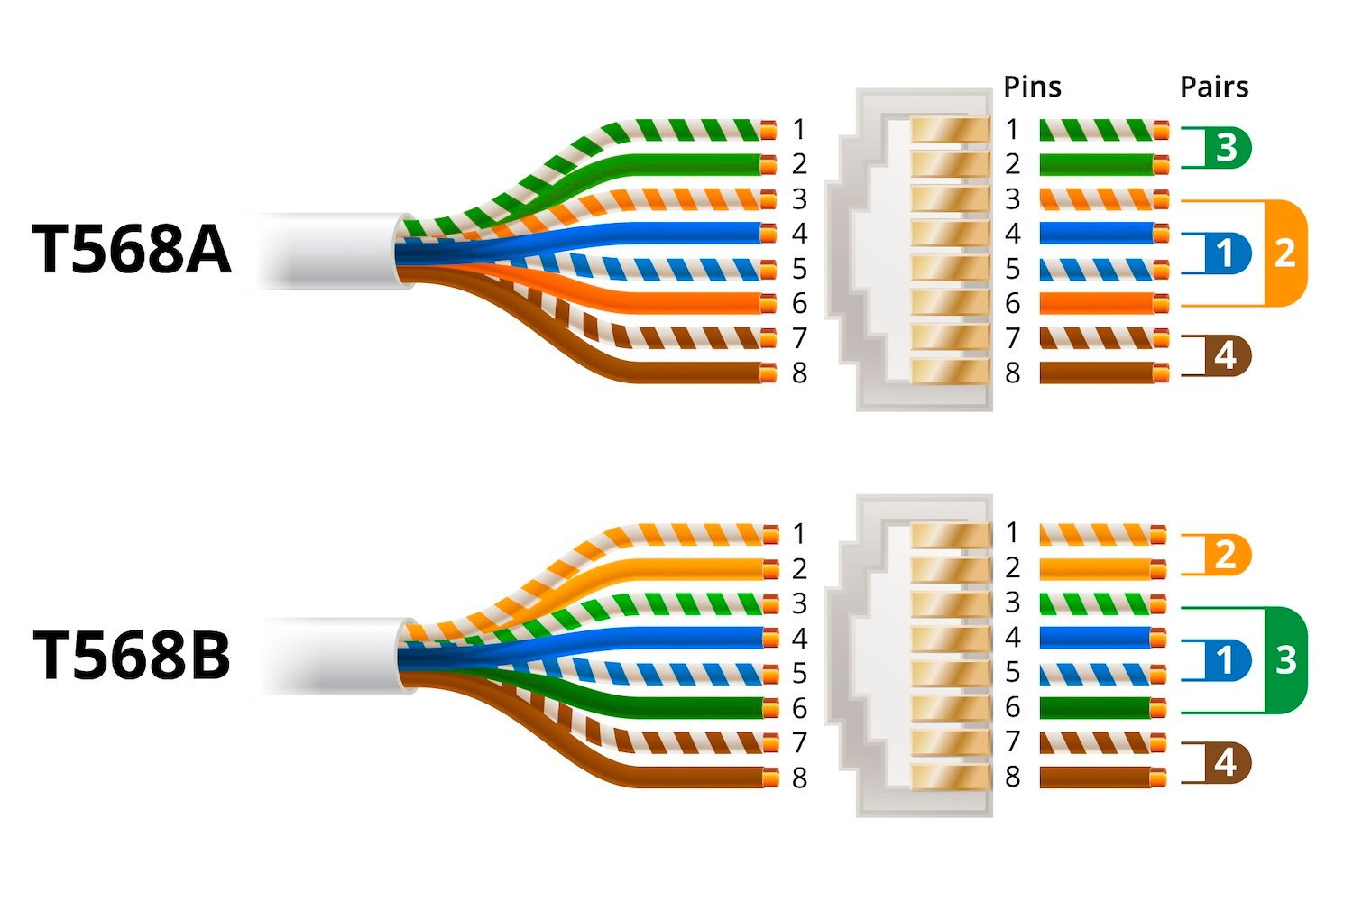

Steps to Form CAT-6 Network Cable (Short)
- Cut the cable to the required length.
- Strip the outer jacket (about 1–1.5 inches).
- Untwist and arrange wires according to T568B (or T568A) standard.
- Trim the wires evenly in a straight line.
- Insert wires into RJ-45 connector (ensure correct order).
- Crimp the connector using a crimping tool.
- Test the cable using a LAN cable tester.

Q2. Study of various internetworking devices
Hub, Switches & Routers

Hub
A hub is a basic networking device that connects multiple computers in a network and sends data to all connected devices.

How it works?
- When a device sends data to the hub,
- The hub broadcasts the data to every port,
- All devices receive the data, but only the intended device accepts it.

Characteristics
- Works at Physical Layer (Layer 1) of OSI model
- No intelligence or decision-making ability
- Cannot identify destination device
- Causes data collision

Advantages
- Easy to install and use
- Low cost

Disadvantages
- Poor performance
- No security
- Not used in modern networks

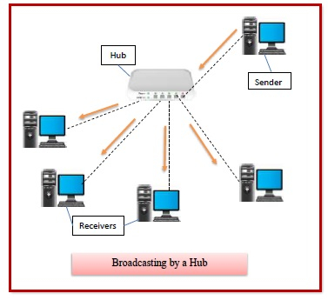

Switches
A switch is a networking device that connects multiple devices in a LAN and sends data only to the specific destination device.
How it works ?
- A switch learns MAC addresses of connected devices
- Stores them in a MAC address table
- Forwards data only to the correct port

Characteristics
- Works at Data Link Layer (Layer 2)
- Reduces collisions
- Faster and smarter than hub

Advantages
- High speed and efficiency
- Better security than hub
- Less network congestion

Disadvantages
- Costlier than hub
- Limited to local networks

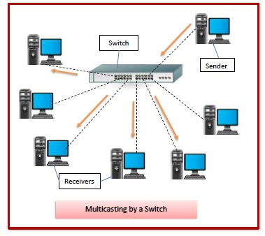

Routers
A router is a networking device that connects different networks and routes data packets using IP addresses.

Working
- Receives data packets
- Checks destination IP address
- Uses routing table to find the best path
- Forwards data to the correct network

Characteristics
- Works at Network Layer (Layer 3)
- Connects LAN to WAN or Internet
- Supports routing protocols

Advantages
- Enables internet connectivity
- Provides security using firewall and NAT
- Efficient traffic management

Disadvantages
- Expensive
- Complex configuration

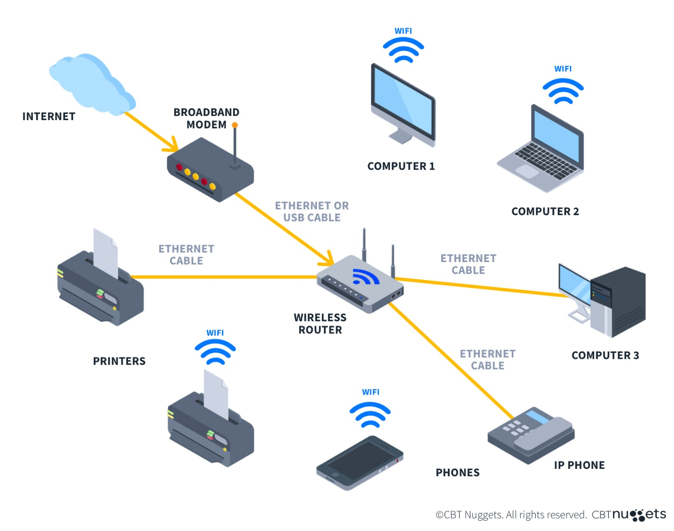

Q3. Demonstration of IP Change and IP Scanner

An IP address (Internet Protocol address) uniquely identifies a device on a network. Changing the IP address and scanning IPs are common network administration and troubleshooting tasks used to manage devices, detect active hosts, and enhance security.

Demonstration of IP Address Change
Objective
To change the IP address of a computer manually and verify the change.

Methods of Changing IP Address
1. Automatic IP (DHCP)
The IP address is assigned automatically by a DHCP server (usually a router).

2. Manual IP (Static IP)
The IP address is manually assigned by the user.

Steps to Change IP Address (Windows – Static IP)
- Open Control Panel → Network and Internet → Network and Sharing Center
- Click Change adapter settings
- Right-click on Ethernet / Wi-Fi → Properties
- Select Internet Protocol Version 4 (IPv4) → Click Properties
- Select Use the following IP address
- Enter:
  - IP Address (e.g., 192.168.1.10)
  - Subnet Mask (e.g., 255.255.255.0)
  - Default Gateway (e.g., 192.168.1.1)
- Click OK to save settings

Verification
Open Command Prompt and type:
ipconfig
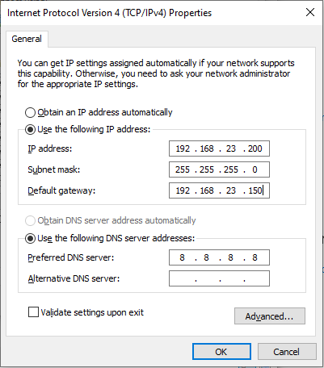

Demonstration of IP Scanner
Objective
To scan a network and identify active devices using an IP scanner.

What is an IP Scanner?
An IP scanner is a tool that scans a range of IP addresses to detect:
- Active devices
- IP addresses
- MAC addresses
- Hostnames
- Open ports (in advanced scanners)

Steps to Use an IP Scanner
- Open the IP scanner tool
- Enter the IP range (e.g., 192.168.1.1 – 192.168.1.254)
- Click Scan
- The scanner displays:
  - Active IPs
  - Device names
  - MAC addresses

Result
All devices connected to the same network are listed with their IP details.

Conclusion
The demonstration of IP address change helps understand network configuration and management. IP scanners are essential tools for detecting active devices and maintaining network security. Both concepts are fundamental in networking and cybersecurity.

